Configurations on router interfaces G0/0/0 and G0/0/1 were made along with configuring the vlan on the switch.
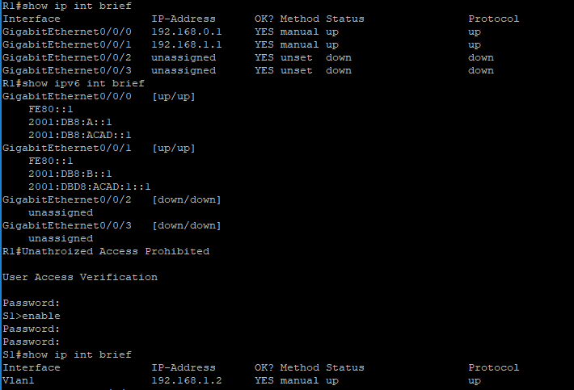
After the configurations were made a ping was made from PC-A to PC-B along the route of PC-A -> S1 -> R1 -> PC-B
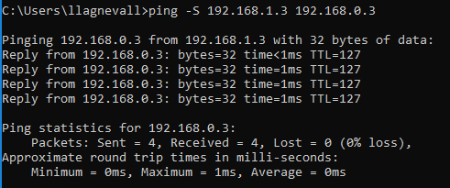

Routing table for the router
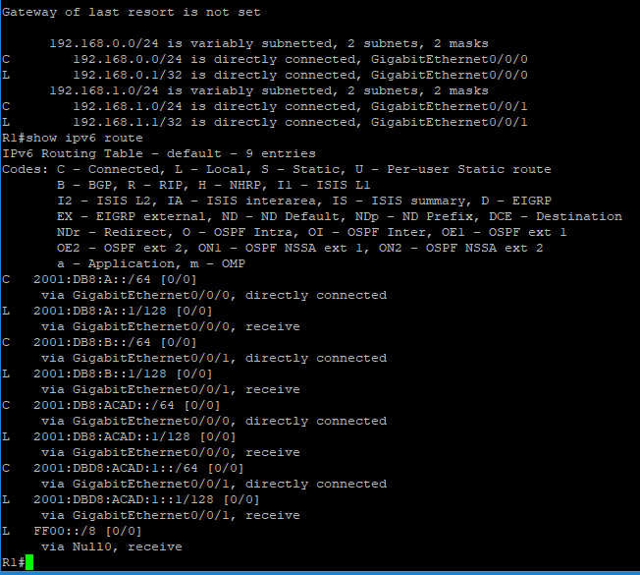
There are two entries marked with a C code, they are the broadcast addresses associated with PC-A and PC-B, with the default gateways marked with an L.
G0/0/1 interface
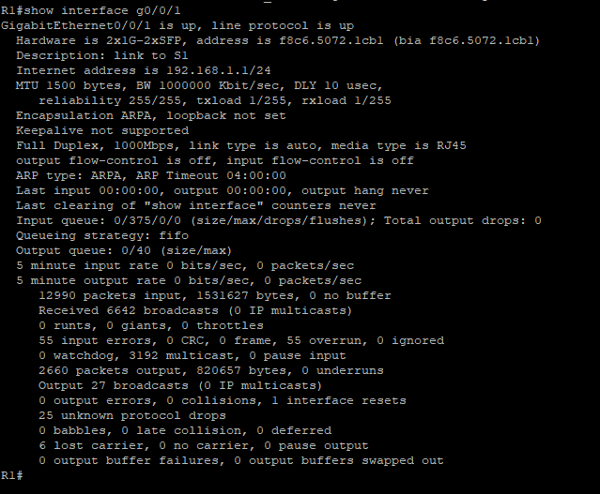
In this screenshot we can see the interface is up with a MAC address of f8c6.5072.1cb1
Internet addresses is displayed in cidr notation
If G0/0/1 was administratively down you would use no shutdown to turn it on
If the router had a conflicting IP with the switch then there would have been a loss of connectivity between the two due to an IP conflict and the ping from PC-A would not have been able to reach PC-B.

